Tracking two pleasures

Aenne A. Brielmann & Denis G. Pelli

**Detailed experimental procedures**

**Stimuli**

We used 36 different images available at <https://github.com/aenneb/tracking2pleasures/tree/master/experiment%20files> from OASIS (<https://osf.io/6pnd7/>).

**Participants**

All participants were recruited via the NYU Psychology Research Participation System. The study was there advertised as “Perception Research”. Participants were invited to take part in this experiment in exchange for one course credit. Participants did not have to meet any eligibility criteria to take part but being registered in the Research Participation System.

**Procedure**

Participants view the images on a 27” iMac Retina LED display (58.2 cm × 36.4 cm, set to 1600 px × 900 px) from a distance of approximately 1 m (so visual angles specified below are approximate). When white, the screen is 500 cd/m2. The room is lit normally. Participants are instructed to “rate how much pleasure you felt from this image (1-9).” It is emphasized that the content of the pictures is irrelevant, and that there are no right or wrong answers. Participants use the keys 1-9 on a standard keyboard to report pleasure from 1 (no pleasure at all) to 9 (very intense pleasure). Participants are told to always keep their eyes on the fixation cross at the center of the screen.

Trial timelines for the different trial types are illustrated in **Figure 1**. Images are presented for 200 ms in their original size (500 px × 400 px, about 10.4 deg × 9.3 deg. Horizontally, the edge of each image nearest to fixation is 89 pixels (about 1.9 deg) from fixation (center of the mark), and its far edge is 51 px (about 1.1 deg) from the edge of the screen. Thus, when two images are shown, they are separated by a 2 × 249 px gap (about 5.2 deg), centered on fixation. A fixation cross of 20 px (about 0.4 deg) width and height is always present in the center of the screen, except while it is replaced by a cue. Cues are presented for 1000 ms. Trials of all blocks have the same sequence and timing except for the shape of the image cue (dot, left arrow, right arrow, or double arrow).

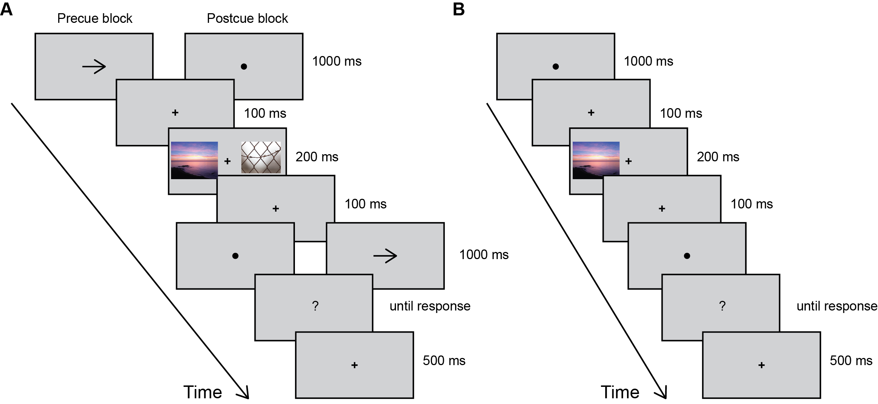

*Figure 1.* Timeline for one example trial for the main experiment (A) and baseline ratings (B).

There are three kinds of blocks. In *pre-cued* blocks, an arrow (left, right, or double) before image presentation indicates whether to rate the pleasure of the left, right, or both images. In *post-cued* blocks, the same arrows are presented after the images. In the final *baseline rating* block, only one image appears on the same side of the fixation cross as it did during pre- and post-cued blocks.

Participants first practice with six training trials, one for each possible image cue (left, right, both), once pre- and once post-cued. As in the actual experiment, pre- and post-cued training trials are blocked and each block contains left-, right-, and both-image cues.

The specifications for the training trials were the same for all participants:

|  |  |  |  |
| --- | --- | --- | --- |
| Pre-/post cue | Image left | Image right | Image cue |
| Pre | Alcohol 3 |  |  |
| Pre | Bar 2 |  |  |
| Pre | Bungee jumping 1 |  |  |
| Post | Bar 2 |  |  |
| Post | Bungee jumping 1 |  |  |
| post | Alcohol 3 |  |  |

After having the opportunity to ask the experimenter questions, observers complete four pre- and four post-cued blocks. In each block, each image is shown once as the target, once as the distractor, and once as part of a pair for which both images pleasure is rated (total *n* = 54 per block). At the beginning of each block participants are told whether cues will appear before or after the stimuli. As the last part of the experiment, participants complete the baseline rating block.

**Verbatim instructions**

Before the experiment started, participants were greeted by the experimenter and given verbal instructions equivalent to the written instructions that were presented on the screen. Participants were encouraged to ask the experimenter any questions after the verbal instructions as well as after completing training trials.

At the beginning of the experiment, participants first read the following instructions on three separate screens:

**Screen 1:** On each trial, you will briefly see a pair of images, one on the left and one on the right.

You will rate how much pleasure you felt from one or both images (1-9).

Arrows will indicate whether to report on the left (<--), right (-->), or both images (<-->).

When making your rating, please ignore whether its a picture of something good or bad.

Just rate how much pleasure you felt, regardless of the goodness or badness of what’s in the picture.

Hit any key to continue.

**Screen 2:** You will use the keys 1-9 on the keyboard to rate the pleasure you felt.

A rating of 1 means that you felt no pleasure at all.

A rating of 9 indicates that you felt very intense pleasure.

There is no right or wrong answer. Just rate how much pleasure you felt. \n

Hit any key to continue.

**Screen 3:** Between the two images, in the middle of the screen, you will see a black cross.

Always keep your eyes on this cross. Do not let your eyes drift away.

Keep your eyes on the cross.

Hit any key to continue.

Immediately after these instructions, participants continued with 6 training trials. The first three trials were pre-cued and introduced like all pre-cued blocks in the main experiment. The second three trials were post-cued and introduced like all post-cued blocks in the main experiment.

The training instructions provided were:

**Training start:** You will now do some training trials to get you used to your task.

Hit any key to continue.

**Training end:** Thank you. You have finsihed your prectice trials.

Please call the experimenter.

Hit any key to continue.

Throughout the experiment, pre- and post-cued blocks were preceded by the following instructions:

**Pre-cued block:** In this block of the experiment, we will tell you which images to report on BEFORE they appear.

Keep your eyes on the cross in the middle of the screen. Do not let your eyes drift away.

Remember: Report only how much pleasure you felt, not the images goodness or badness.

Rate by hitting a key from 1 (no pleasure at all) to 9 (very intense pleasure).

Hit any key to continue.

**Post-cued block:** In this block of the experiment, we will tell you which images to report on AFTER they appear.

Keep your eyes on the cross in the middle of the screen. Do not let your eyes drift away.

Remember: Report only how much pleasure you felt, not the images goodness or badness.

Rate by hitting a key from 1 (no pleasure at all) to 9 (very intense pleasure).

Hit any key to continue.

When participants had no further questions, the experimenter left the room and the participant completed the first, main part of the study at her own pace.

**Experiment start screen:** You will now start the actual experiment.

Hit any key to continue.

After finishing the first part of the experiment, the experimenter was called back into the room and started a separate script for the single-image baseline ratings. Again, brief verbal instructions preceded the following written instructions:

**Screen 1:** On each trial, you will briefly see one image.

It will either be shown on the left or right side of the screen.

You will rate how much pleasure you felt from this image (1-9).

When making your rating, please ignore whether it's a picture of something good or bad.

Just rate how much pleasure you felt, regardless of the goodness or badness of what's in the picture.

Hit any key to continue.

**Screen 2:** You will use the keys 1-9 on the keyboard to rate the pleasure you felt.

A rating of 1 means that you felt no pleasure at all.

A rating of 9 indicates that you felt very intense pleasure.

There is no right or wrong answer. Just rate how much pleasure you felt.

Hit any key to continue.

**Screen 1:** Between the two images, in the middle of the screen, you will see a black cross.

Always keep your eyes on this cross. Do not let your eyes drift away.

Keep your eyes on the cross.

Hit any key to continue.

**Exact randomization procedures**

**Main experiment**

For each participant, the following rules were used to create a randomized trial structure using the scripts available at <https://github.com/aenneb/tracking2pleasures/tree/master/experiment%20files>. Randomization occurred every 2 blocks, i.e., each time a participant had completed one pre- and one post-cued block.

Trial specifications for the main experiment were set up in triplets within which each image was shown once as target on the left, once as distractor image, and once as part of a combined-pleasure rating trial. At the same time, no image was paired with the same other image twice. Triplets were set up separately for pre- and post-cued blocks with the additional restriction that image-pairings were also not repeated between pre- and post-cued blocks.

Based on these restrictions, an initial trial structure that contained (1) the image to be shown on the left, (2) the image to be shown on the right, and (3) the kind of cue displayed (left, right, both) was constructed. Next, the order of these trials was randomized using the Shuffle() function built into Psychtoolbox (<http://psychtoolbox.org/>). Last, any repetitions of the same image on either the left or right side was removed from the initial randomized sequence by swapping trials until no image was presented twice in a row anymore.

**Single-image baseline ratings**

For the single image ratings, trials were randomized for each participant by first randomly assigning a presentation side to each image and then shuffling the order of image presentation. Both image presentation side and trial order were randomized using the Shuffle() function built into Psychtoolbox (<http://psychtoolbox.org/>).